Partner Success Handbook

Table of Contents:
Setting Up Your Partner Portal/ Getting Started
Equipment/Filming
Music
Content Quality
Going LIVE on the Platform
Posting Classes On-Demand
Marketing: How to Promote Your Brand and boost performance/revenue
Payment Overview
Exclusivity
Discounts
Additional Resources

Getting Started
- Partner Orientation
- Create Your Account
- Complete Your Instructor Profile
  - Profile Picture must be 1 MB or less
    - Business profile remains the Burnalong logo
  - Your certifications and bio must be completed in order to upload a class
  - If you do not see your certification listed in the drop down menu; please email the title of your certification and a copy of the associated certificate to partners@burnalong.com
- Add more instructors to your profile
- Class Categories
  - Choose up to three. Think big picture. This is the main focus/goal of the class.
  - For example, for a class consisting of upper body exercises: “arms” and “upper body'' would be appropriate categories. While the core is engaged during such exercises, and the legs may be involved in the class, they are not involved in the “goal” of the class.
    - Use “Zones” For accessory areas that are involved/worked on
  - Where relevant you may only tag categories that you hold a license to teach. For example, you may only tag “mental health” if you are licensed in that field.
- Printable Handouts: Have a class “handout you want to include?”
  - Create a public google drive document open to everyone. Drop that link in the class description
- Class Difficulty Levels: 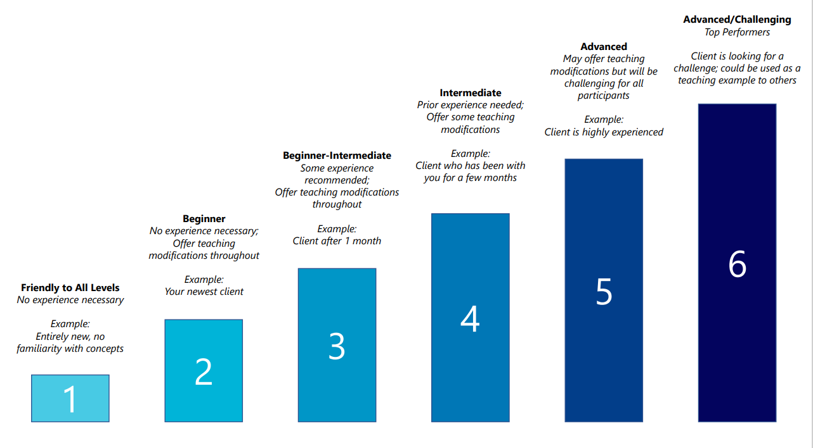

Equipment/Filming

- Filming Best Practices
- Equipment Recommendations
- Only MP4 files are compatible with the platform

Music
- Use royalty-free music.
- Use music that you have purchased the rights to.
- Remove music during the class but add a link in the class description to the Spotify / Pandora (or other streaming service) playlist you use . (Note– it is possible to remove the sound after the class is recorded).
- Don’t include music, and invite the user to play their favorite music in the background in your class description and in the class intro.
- Live streaming may provide more flexibility based on the licenses you already have.

Content Quality
- Don’t be afraid to be yourself! You can let your personality come out and add your own flare to your content.
- Speak with conviction and energy

Class Introductions and Closings and Format:
- Your class introduction should be a quick welcome to the class (15-30 seconds) and should include:
  - Your name
  - The expectation for the class
  - Who the class is for
  - Any equipment needed (can be a pen and paper!)
  - Any extra information that is relevant or a word of encouragement
- Your class closing should include:
  - A congratulatory response or thank you (how would you end an in person class or session?)
  - Asking for the user to schedule their next class with you (a specific class to suggest can go a long way!)
  - Asking for a review and a comment if they enjoyed the class
  - A kind goodbye!
- Evaluate your Class Quality: Instructor Rubric

Visual
- Clear, crisp and bright picture, angle is straight on.
- The best lighting is natural lighting from in front of you. You can use tools like ring lights to help quality visually
  - Be aware that overhead lighting may cause shadows and/or graininess
- There are no interruptions visually. All people/props that are seen, are there intentionally with a purpose whether for a backdrop, or related to the execution of the content. Ex. Your dog or child does not run by at any time if they are not a part of the class. They are more than welcome in “Mommy and Me” like classes, or doggy workouts!
- Videos must be filmed horizontally. Vertical videos will be removed from the platform
- For non movement related classes, remain at atleast an arms length distance from the camera
- Wear clean professional tops and bottoms
- Camera is steady

Audio
- Using a microphone can help audio quality especially when using music with your videos
- Audio should be able to stand alone in your videos
- Pay attention to background noise such as fans, construction, or others in the house. All sound should be planned and intentional.
- Use Professional Language (no profanity)

Going Live on the Platform
- By scheduling a live class, you will show up on the “LIVE Class Calendar” section of a user’s homepage. For maximum visibility benefits, we recommend going live at the same time every week.
- How to Go LIVE: LIVE Webinar Recording
- Scheduling Live:
  - Live classes should be scheduled in the partner portal and video type should show “Live”
  - You will be able to schedule date and time of class
  - 5 Minutes before class starts, head back into the class under the “Classes” Tab and find the class title
  - Hit “View”
  - Scroll to the bottom of the page and you will see “Stream Now”
  - Upon hitting “Stream Now” You will see a 5 second count down and your class will be immediately live.
- Pausing, Muting, and Connection
  - When you enter into your Live class, you will see “Mute,” “Pause Video,” “Network,” and “Leave Now”
  - The “Pause Video” button will turn your video off. The time you are paused, will not show up in your recording
  - You can Leave and Re-enter at any time during the class, however, we would not recommend this
- Canceling a Live Class
  - If you have to cancel your live class, please leave the class active, but change the title to “*Current Title* CANCELED” for example if your live class is titled “Arms and Abs” it becomes “Arms and Abs CANCELED.” This way users know the class has been canceled when they log in.
- Network Connection
  - The “Network” Button will show your sending and receiving video and audio quality. If you are having trouble during the live class, check your connection!
  - Going Live on a network that also is streaming or has multiple people on it may affect your live quality.

Live Streaming Best Practices:
- Setting a consistent schedule and sticking to it! Users want to get into a routine, and you can help make that happen!
- Make sure your lighting and audio are ready to go!
- Do a test class by creating a class titled “TEST” in the partner portal
- Market your class! Let your users know on social media, in on demand classes, in your descriptions, and in your studios!
- Classes should feel like classes, introduce yourself, ask for reviews, ask people to comment where they are from after the class is over, bring the energy and remember you ARE talking to people in real time!

Posting Live Classes On Demand:
- WIthin 24 hours of going live, your live class will be ready to post on-demand.
  - Find your class and Click “View”
  - Scroll to the bottom of the page and click “Publish Live Recording”
  - Choose your thumbnail and click “Set Active!
  - Your class will appear in your on-demand Library!
- Incentive: Upload 4 classes in your first 30 days to receive the bonus!
  - Videos must meet the quality requirements detailed in the following section labeled “Quality.”

How to Upload an On-Demand Class
- Class Thumbnails: A photo is taken every 5 minutes of your class. Ex. If your class is less than 10 minutes, that one photo will be automatically selected as the cover image. If your class is 12 minutes, you will have two options. For classes under 5 minutes, the class will appear black

Marketing: How to Promote Your Brand and boost performance/revenue
- Discount Codes: Request Partner Codes from partners@burnalong.com.
  - Use promo codes to encourage users to join Burnalong and watch your classes!
- Marketing: Promote yourself using the social media tool kit
- Consistency: The more consistent you are, the better! When you consider a profile that has 1 video versus one with 100, you will be more likely to stick with an instructor that has more classes and consistently has new classes for you to choose from!
  - Depending on how often you want users logging into your classes, you should have that amount of content coming out regularly so they can be consistent with you.
- Increase Visibility of your classes on the Platform
  - Going Live on a regular and consistent schedule can also help bring people into your burnalong circle. See going LIVE section below for recommendations.
  - Build a program
- Reviews: it is no secret that when we buy or try anything, we read some reviews. The same thing goes on Burnalong! Reviews can help others click into your videos and your replies create the feeling of connection between you and users.
- Partner Newsletter: Make sure you read through the partner newsletters! They have all the information about requested class content, upcoming events, and more important updates about your burnalong partnership.
- Submitting Requested Content: We will request specific content based on what our clients are asking for. When content is requested, make sure to utilize the form that is given to submit your classes!
- Additional Opportunities:
  - LIVE Webinars, On site Events (candidates are chosen based on classes that meet level 5 criteria in all sections of the instructor rubric.)
  - Burnalong is a great way for instructors and clients to make an initial connection or to work together between in-person sessions. We encourage Burnalong instructors to let local users know how to find them offline.

Payment Overview

- Step 1: Instructors will receive an email invitation to our electronic payment system called Justworks after their 4th class has been posted to Burnalong. Bank information for direct deposit will be entered by the instructor at that time.
  - *If a JustWorks account is not created by the time payments are set to go out,, the instructor will not be able to get paid.*
- Step 2: Each month, Burnalong sets aside a percentage of our subscription revenue as a pool to be shared with our partners.
- Step 3: We divide that percentage among the partners based on the minutes that their classes are viewed as a percentage of total minutes viewed.
- Step 4: At the end of each quarter we total up everything and send you a payment. If a payment is earned, you can expect it up to 45 days after the quarter ends.
  - As an example only, if your classes account for 1% of the total minutes viewed on the platform in a particular month, you’ll get 1% of the revenue share pool.
- We do have a payout minimum. Burnalong issues payments to instructors who have earned at least $25. If you earn less than $25 the amount is rolled into the next quarter and will be paid out once the $25 threshold has been met.
- To receive the minimum payment, it is estimated that a partner would need to accumulate 150-200 minutes viewed by Burnalong users.
  - Partners will not be paid out for minutes viewed by any owners or instructors within your partner organization.

Why Would My Classes Get Taken Down/Deactivated?
- Use of Profanity
- The class has clearly been repurposed from an alternate platform (Facebook Live, YouTube, Zoom, etc)
- The video does not follow the class format as described above
- The class is vertical
- The camera is significantly unsteady
- Your class content is outside the scope of your certifications/licenses

Exclusivity
- We do require exclusivity from our partners because BurnAlong clients are promised unique and exclusive content.
- Partners that are exclusive to BurnAlong are also the ones that see the most success! We have partners earning thousands of dollars every quarter because they chose us for their virtual platform to service their clients and get introduced to ours.
- In return for this exclusivity, we provide marketing, promotion, and various other opportunities to get in front of hundreds of thousands of users. We also provide all of the technology, host the platform, and provide you, and any users you bring along with you, tech support.
- You are welcome to post teasers and other promotional content on your social media in order to direct your followers to BurnAlong using your promo code.

Discounts
- Discounted Resources For Instructors
  - Music, ongoing certifications, conferences and events etc

Additional Resources
- Partner Training Library
- Partner FAQ
- Partner Agreement
- Partner Facebook Group
- 2022 Q1 Webinar: Tips From Top Instructor on to play the long game for success on Burnalong
- Partner Information and Communication
  - Partner Onboarding Q&A:
    - Tuesday @ 3:30 pm & Thursday’s @ 12:30 pm EST:
  - Bi-weekly Newsletters
  - Quarterly Webinars (1st week of every new quarter)
  - Monthly Partner Education, 3rd Thursday of every month, 1:00 PM EST

